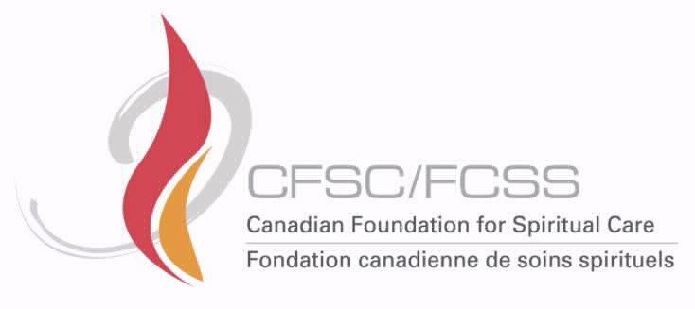

Foundation MINUTES
Wednesday October 13, 2021
11:00 PDT; 12:00 MST; 1:00 CST; 2:00 EST; 3:00 AST; NDT 3:30
Present ( )
 | Kim Bustard, PRESIDENT (Atlantic) |  | Paul Wilkie, ATLANTIC
R | Tom Powell, PAST PRESIDENT (Saskatchewan) |  | Vacant, QUEBEC
 | Jan Temple-Jones, VICE PRESIDENT (SWONT) |  | Ed Montano, ONE
 | Don Misener, TREASURER (Ontario North East) | R | Stephen Hudecki, ONCN
 | Angela King, SECRETARY (Alberta) |  | Joan Silcox-Smith, SWONT
 | John Hayward, Executive Director |  | Lori Jorgenson, MANITOBA
 | Rochelle Blackwood, Manager of Operations |  | Audrey Mierau Bechtel SASKATCHEWAN
 |  |  | Wenda Salomons, ALBERTA
 |  |  | Don Cowie, BRITISH COLUMBIA

- Welcome

- Reflection (Kim)

- Combined Proposal update (John)
In a couple of weeks, John will be sending out a progress report to update CASC/ACSS Board, CFSC/FCSS Board and the Working Group about what’s happened so far and what steps we will be taking next. A working group (made up of some CASC Board members, some CFSC Board members, and members of CASC at large) have received an “Interviewee Profile” in October. The working group will review this information and give names to the FCM project leads. At this meeting, the Foundation members asked if they could also get a copy of the Profile and asked if they too could submit names. John Hayward felt this was a great idea and stated that he would get the Profile information out to this committee and asked them to submit names so that a list could be created by the FCM leads. The FCM Leads will then work through the list and interview appropriate candidates from there. Additionally, CASC and CFSC members will also be interviewed. The point of interviews initiative is to assist FCM in compiling a practical analysis, identify best practices, and develop an actionable plan to ensure that we have sustainable revenue for the future.

ACTION ITEM: John to send out the contract to Foundation members to review again (maybe get John to check this. I think he was going to send out additional information too.)

QUESTIONS:
- Who does the report go to? How long will the interviews take, how many people?
John: There are two reports. The report coming out in a week and a half is written by John and will go to CASC/ACSS Board, CFSC/FCSS and the Working Group. It’s a progress report. The interviews FCM will conduct (30-40 people) is expected to take about a month taking us into the end of November. CFSC/FCSS will have an opportunity to review FCM’s report and address any concerns or questions and that time and make adjustments.

- Do you need assistance?
John: Thanks. Working Group will be identifying people to be interviewed but if anyone on the Foundation knows of KEY external people that should be contacted by FCM, let John know who they are. (Healthcare/Agencies/Government). FCM has a letter that will be sent out to prospective interviewees asking if they are open to an interview.

- Can we fan out the asks if our colleagues are more likely to have the contacts?
John: Yes, of course.

ACTION ITEM: John will send a copy of the letter to Working Group, CASC/ACSS Board and CFSC/FCSS before the end of the week.

Regional Report Question:
A question was asked in regard to the Reports For Regional AGM’s. Some of the foundation reps have reported or were waiting on a report both in regard to the CFSC activity and this new Project.
ACTION ITEM 1: Angela and John/Rochelle both thought they could provide a Regional Report and a written update to the foundation reps within the next two weeks.
ACTION ITEM 2: Rochelle will create a “Foundation” section on the members section of the website. The report to the Regional AGMs can be placed here as well as any new information, ideas, etc.

- Treasures update (Don)
CASC Financial Update October 13, 2021
Account balance May 31, 2021 $346,845.57
Outstanding growth from our Jan 1, 2021 balance of $307,433

Account balances as of October 12, 2021
Investments Account $301.152 (after transfer of $50,000 to Foundation Bank Account)
Bank Account Balance after transfer $54,542.31)
Account balance after first instalment to PRFund dev. Strategy of $19,775 - $34,542.31
Amount owing to PR Fund dev. Strategy will be paid out at the completion of the project.

Current Bank Account for use to cover costs of Bursaries $34,542.31
Bursary Awards in 2020 $14,000

QUESTIONS:
- Where does the $14,000 come from? Can it be topped up? Can we award more than $19,000? What about the timing of the bursaries?
John: We still have the money in the bank, if we want to distribute $19,000 in bursaries, we will just have to transfer money at the end of the year.
Don: Originally, bursaries were always given in the spring. Then we were asked to distribute in the fall. We are considering 2x a year.
Kim: As we gain momentum, it may be worth considering 2x a year but there are also things to consider like how to promote the bursaries, how much money to give out each time, whether someone receiving monies in the fall can also receive monies in the spring?
Don: I believe we should be far more generous in our awards; there is a greater opportunity to provide assistance especially for research. We should award it.

- Are we spending interest or principle?
John: We are spending interest.
- How often do we want to have an application for Bursaries (once a year or twice a year and do we provide a research grant?
- There was a suggestion to make the actual application form less complicated.
Don: I think we should designate a certain percentage of our earnings towards bursaries and grants and thus be more generous in awarding bursaries.

Motion to receive report made by Don Misener.
Seconded: Paul
Carried.

ACTION ITEM: Angela to update the CFSC/FCSS report to Regional AGMs to reflect the Treasurer’s latest information.

- Update Letter to be placed on Website (Angela)
The Letter from the Foundation will be available once the bursaries are awarded next week.

- Vote of going forth on review some applications (all)
At next week’s meeting we will receive a Motion to consider an amount to award as bursaries.

Discussion took place around the applications received by the deadline.

- Review of applications 1-10 (if the above vote is in the affirmative (all)
Deferred.

Next meeting: Monday, October 18, 2021
11:00 PDT; 12:00 MST; 1:00 CST; 2:00 EST; 3:00 AST; NDT 3:30

