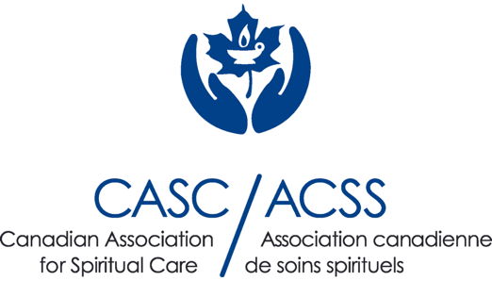

FOR IMMEDIATE RELEASE

Canadian Association for Spiritual Care/Association Canadienne de soins spirituels
John Hayward, Executive Director
416-627-1333
jhayward@spiritualcare.ca
spiritualcare.ca

SPIRITUAL HEALTH IS HEALTH

Embracing a holistic approach to well-being

[Toronto, September 29th, 2023] – Spiritual Care Awareness Week (SCAW) is around the corner, taking place October 22-28, 2023. This week is an opportunity for individuals to celebrate spiritual care professionals, including Spiritual Care Practitioners, Psychospiritual Therapists, and chaplains alike for their unrelenting commitment to the wellbeing of Canadians.
The Canadian Association for Spiritual Care/Association Canadienne de soins spirituels (CASC/ACSS) represents a group of professionals united in their belief that spiritual health is inseparable from overall health, and that addressing spiritual needs is a necessary component in alleviating suffering and promoting healing. CASC/ACSS is currently leading the conversation for SCAW, by promoting a critical message across the Canadian landscape: “Spiritual Health IS Health”. Here spirituality does not refer to any particular religion, but instead encompasses the universal and powerful experience of meaning making and finding purpose.
Society has come a long way in recognizing mental and emotional health as a key component of overall health. Now is the time to take this a step further, and collectively acknowledge spiritual health as an integral part of holistic well-being. The Association is proud to reveal its new ground-breaking narrative, which summarizes the core of what CACS/ACSS professionals do:

1. Connecting with the Body: Facilitate an awareness of how the sacred is being experienced in and through the body.

2. Engaging with the Mind: Engage with and bring attention to the stories that shape individuals and communities.

3. Embracing the Emotions: Welcome and hold space for the full range of human emotions.

4. Supporting the Human Spirit: Develop and sustain a sense of wellbeing in the face of changing circumstances.

Canada has started to recognize the critical role of spiritual care in the healthcare sector. For example, the latest revision of The Canadian Interdisciplinary Palliative Care Competency Framework, a document created in collaboration with Health Canada, incorporates spiritual care competencies and considers them essential in the provision of high-quality palliative care. At the same time, spiritual care and psychospiritual therapy remains largely unrecognized in mainstream discourse, and underutilized in other sectors in which it is relevant, including counselling clinics, mental health facilities, prisons, the military, addiction clinics, homeless shelters and more. Raising awareness about spiritual care can ensure more Canadians know about this essential profession and encourage important conversations about this work. Doing so will help create a world where individuals can flourish physically, mentally, emotionally, and spiritually. #spiritualhealthishealth.

Join the Movement
CASC/ACSS is a national multi-faith organization, committed to the professional education, Certification and support of people involved in spiritual care, psycho-spiritual therapy, education, and research. For more information, visit spiritualcare.ca. We welcome partnerships, collaborations, and contributions from individuals, professionals, and organizations passionate about fostering spiritual well-being across Canada.

